Particle in a Box (1 Dimension)
The time independent Schrödinger equation for a particle equation moving in one dimension:
$$-\frac{ℏ^{2}}{2m}\frac{d^{2}ψ\left(x\right)}{dx^{2}}+V\left(x\right)ψ\left(x\right)=Eψ(x)$$
Where:
$$ℏ$$ | $\frac{h}{2π}$ (reduced Plank’s constant)
$$h$$ | Plank’s constant (describes size of quanta in quantum mechanics)
$$m$$ | mass of particle
$$ψ$$ | wave function (replaces the concept of trajectory in classical mechanics)
$$V(x)$$ | potential energy of particle
$$E$$ | total energy of particle
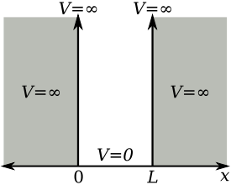
For a particle in a one-dimensional box of length $L$ ,the potential energy function is
$V\left(x\right)=\left\{\begin{aligned}0 0<x<L \\ ∞ \text{elsewhere}\end{aligned}\right.$.
This implies that the particle can only exist inside the box where $V\left(x\right)=0$.

Therefore:
$$-\frac{ℏ^{2}}{2m}\frac{d^{2}ψ}{dx^{2}}=Eψ→\frac{d^{2}ψ}{dx^{2}}+\frac{2mE}{ℏ^{2}}ψ=0$$
.
Let:
$$k^{2}=\frac{2mE}{ℏ^{2}} →\frac{d^{2}ψ}{dx^{2}}+k^{2}ψ=0$$
We have now reduced that equation to a homogeneous second order differential equation with constant coefficients. We have shown earlier that the general solution to this equation is:
$$ψ\left(x\right)=c_{1}\sin\left(kx\right)+c_{2}cos⁡(kx)$$
The infinite potential outside of the box implies the following boundary conditions:
$$ψ\left(\text{0}\right)\text{=0 and }ψ\left(L\right)\text{=0}$$
Furthermore, we can consider that $ψ\text{=0}$ for any point outside the box. Applying the first boundary condition:
$$ψ\left(0\right)=c_{1}\sin\left(0\right)+c_{2}\cos\left(0\right)=0 → c_{2}=0 → ψ\left(x\right)=c_{1}\sin\left(kx\right)$$
Applying the second boundary condition:
$$c_{1}\sin\left(kL\right)=0 →kL=nπ →k=\frac{nπ}{L}$$
where n is an integer. Therefore:
$$ψ_{n}\left(x\right)=c_{1}\sin\left(\frac{nπx}{L}\right)$$
Note that the subscript on$ψ$ indicates that there are different solutions for different values of n. We now need to determine $c_{1}$. Recall that:
$${\left|ψ_{n}\left(x\right)\right|}^{2}=\int_{0}^{L}{{ψ_{n}\left(x\right)}^{2}dx=\int_{0}^{L}{c_{1}^{2}\sin^{2}\left(\frac{nπx}{L}\right)dx}}=c_{1}^{2}\int_{0}^{L}{\sin^{2}\left(\frac{nπx}{L}\right)dx}$$
Since ${\left|ψ_{n}\left(x\right)\right|}^{2}$ represents the probability distribution function and we know that the particle will be somewhere in the box, we know that ${\left|ψ_{n}\left(x\right)\right|}^{2}$=1 for $0<x<L$, i.e. there is a 100% probability that the particle is somewhere inside the box. Therefore:
$$c_{1}^{2}\int_{0}^{L}{\sin^{2}\left(\frac{nπx}{L}\right)dx}=1$$
We can show that:
$$\int_{0}^{L}{\sin^{2}\left(\frac{nπx}{L}\right)dx}=L\left(\frac{1}{2}-\frac{\sin\left(nπ\right)cos⁡(nπ)}{2nπ}\right)$$
This is the solution as it appears on the TI Voyage 200, but since n is an integer,$\sin\left(nπ\right)=0$. Hence:
$$\int_{0}^{L}{\sin^{2}\left(\frac{nπx}{L}\right)dx}=\frac{L}{2}$$

and:
$$\frac{c_{1}^{2}L}{2}=1 → c_{1}=\sqrt{\frac{2}{L}}$$
thus:
$$\boxed{ψ_{n}\left(x\right)=\sqrt{\frac{2}{L}}\sin\left(\frac{nπx}{L}\right)}$$
This is the solution to the wave equation for the particle in a one dimensional box.
We now turn our attention to the total energy. Recall:
$$k^{2}=\frac{2mE}{ℏ^{2}}$$
Since:
$k=\frac{nπ}{L}$ and $ℏ=\frac{h}{2π}$
We get:
$$E=\frac{ℏ^{2}k^{2}}{2m}=\frac{h^{2}}{4π^{2}}\frac{n^{2}π^{2}}{L^{2}}\frac{1}{2m}→ \boxed{E=\frac{{n^{2}h}^{2}}{8{mL}^{2}}}$$
Thus the energy is quantized (since n=1,2,3, … and all other terms are constant). The wave functions and probability functions are plotted below for a box with length $L=1$ for corresponding energy levels. Note that the plots have been shifted up by $n^{2}$ for display purposes.
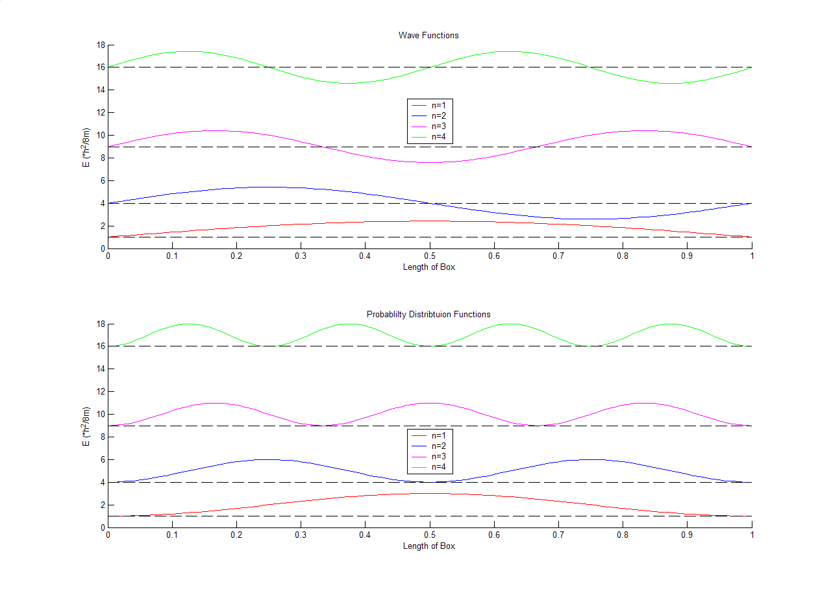

With regards to the wave functions, we define a node as a location other that the endpoint where $ψ_{n}\left(x\right)=0$. Note that there are $n-1$ nodes that correspond to each energy level. Consider $n=2$, there is one node. If we consider the probability distribution function for $n=2$, we see that it equals 0 at $1/2$. If this is the case, how can a particle get from the left-half to the right-half of the box? You will discuss a phenomenon called “tunneling” in subsequent chemistry classes to explain this behavior.
Example:
What is the probability that a particle in the ground state will be found between L/2 and 2L/3? (note: ground state means $n=1)$
$$\int_{L/2}^{2L/3}{{\left|ψ_{n}\left(x\right)\right|}^{2}dx}=\int_{L/2}^{2L/3}{{\left|\sqrt{\frac{2}{L}}\sin\left(\frac{πx}{L}\right)\right|}^{2}dx=\frac{2}{L}\int_{L/2}^{2L/3}{{\left(\sin\left(\frac{πx}{L}\right)\right)}^{2}dx=}.3044 or 30.44\%}$$

Homework
- For the potential well describes in these notes, what is the probability that a particle in the 2nd energy level will be found between L/2 and 2L/3.
- Assume that for the particle-in-box described in these notes that the potential energy inside the box V(x)=1. Assume that the box goes from x=0 to x=2L. Find $ψ(x)$. Find an expression for E in terms of n, h, m, and L.
- In problem 2, what is the probability that a particle in the 3rd energy level will be found between L/2 and 2L/3.

